Name : Dhavalkumar Vijaykumar Patel
Subject : Essential of Cyber Security and Cyber Waefare
Class : M.Sc Cyber Security
Semester : 1

Lab 3 :
Practical related to:
Employing
the Security Configuration and Analysis snap-in, Understanding Local Group
Policy Objects, Understanding Domain Group Policy Objects, Administrative
Users, AppLocker, User Account Control. Checking Recommended GPO settings,
including: Password Policy, Account Lockout Policy, Security Options, Internet
Explorer Security,

Security Configuration and Analysis snap-in
The Security Configuration and Analysis is a stand-alone snap-in tool that users can use to import one or more saved configurations to a private security database. Importing configurations builds a machine-specific security database that stores a composite configuration.

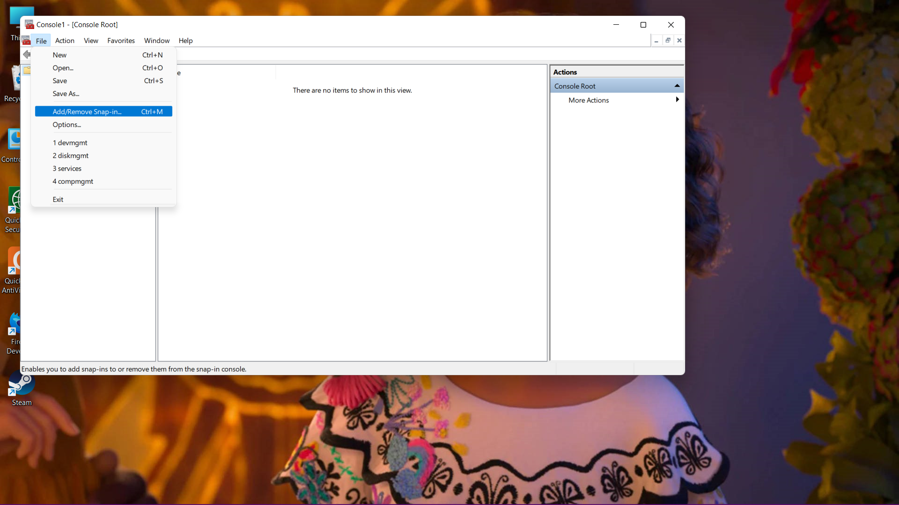

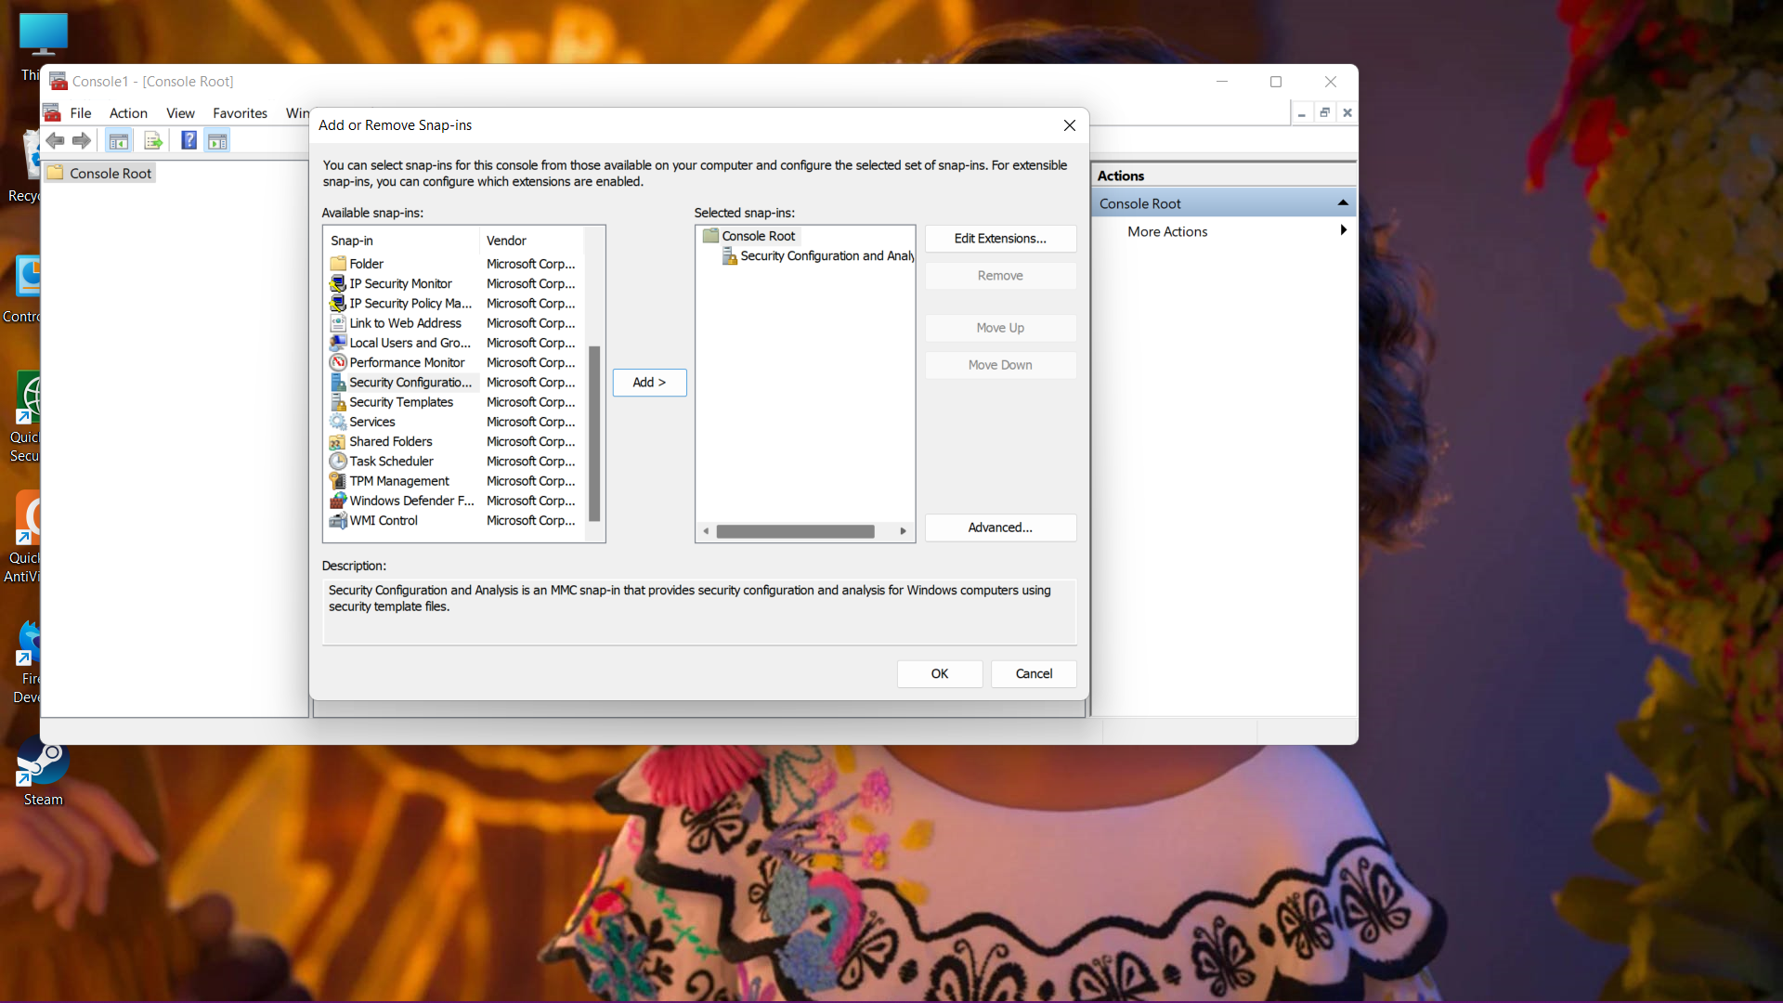

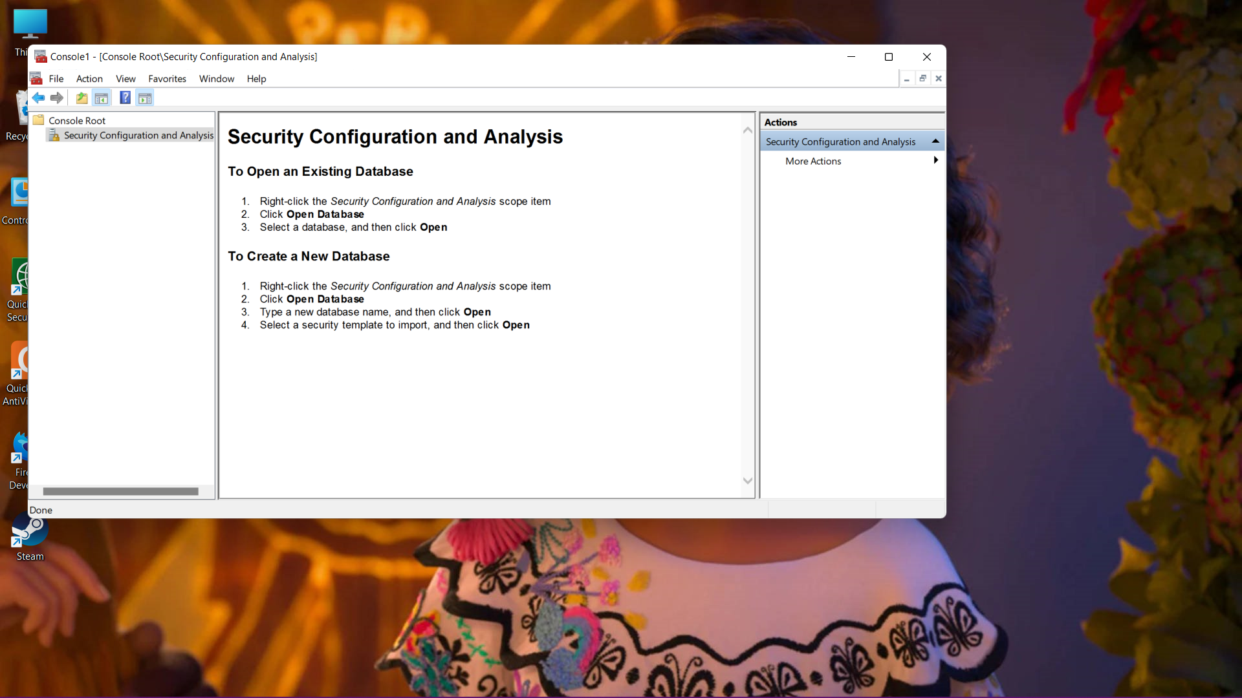

Understanding Local Group Policy Objects
A local Group Policy Objectrefers to the collection of group policy settings that only apply to the local computer and to the users who log on to that computer. Local GPOs are used when policy settings need to apply to a single Windows computer or user. Local GPOs exist by default on all Windows computers.

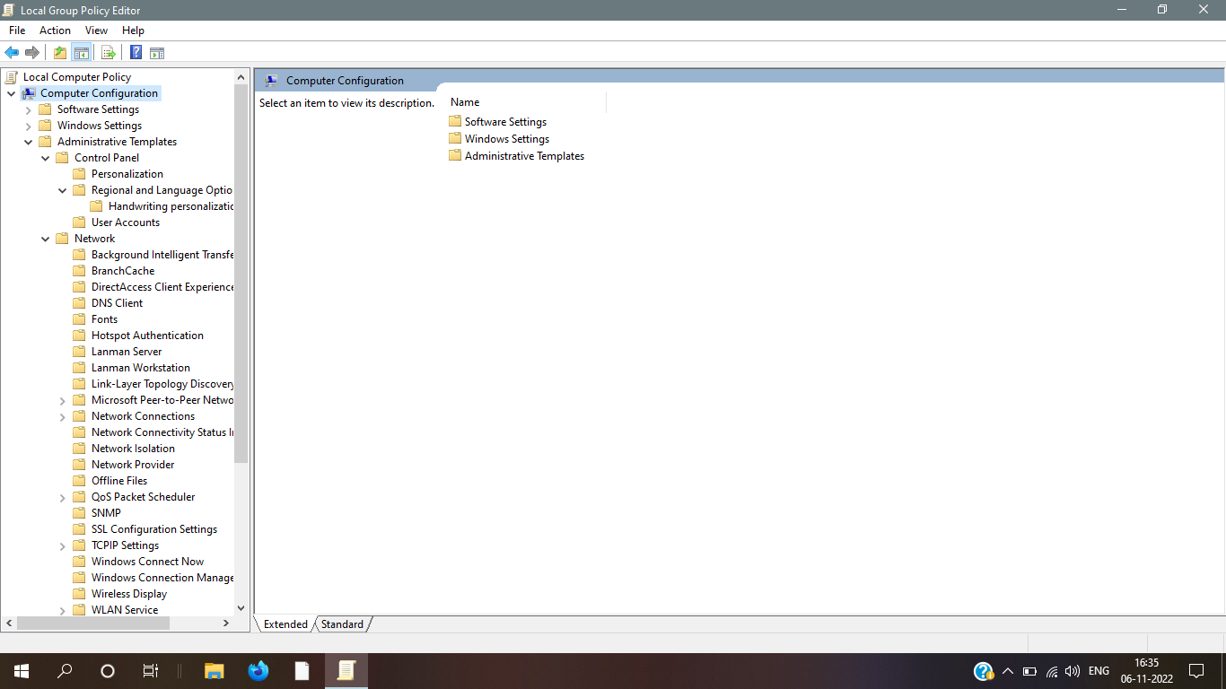

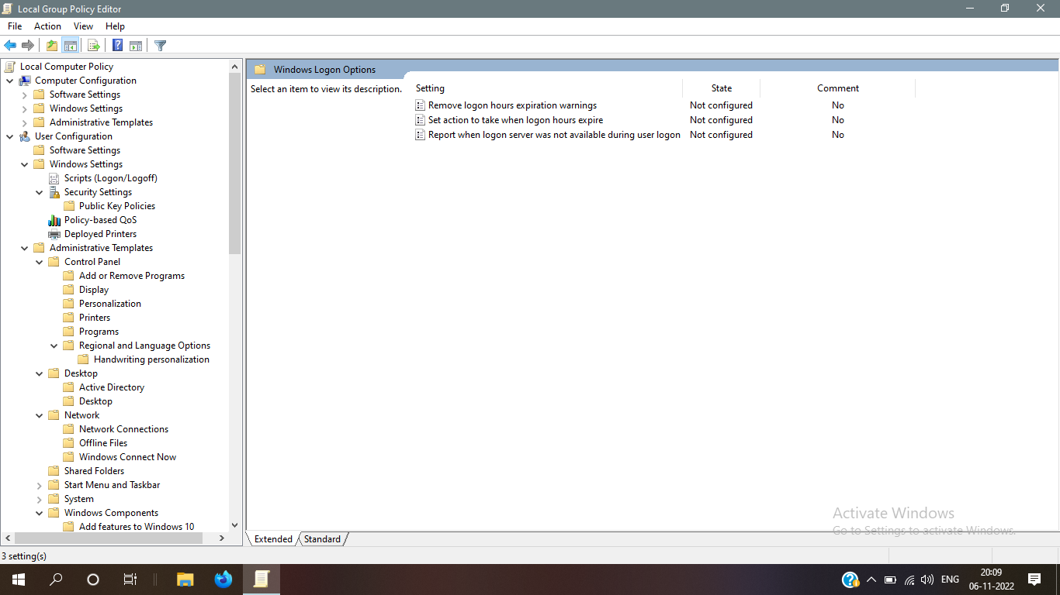

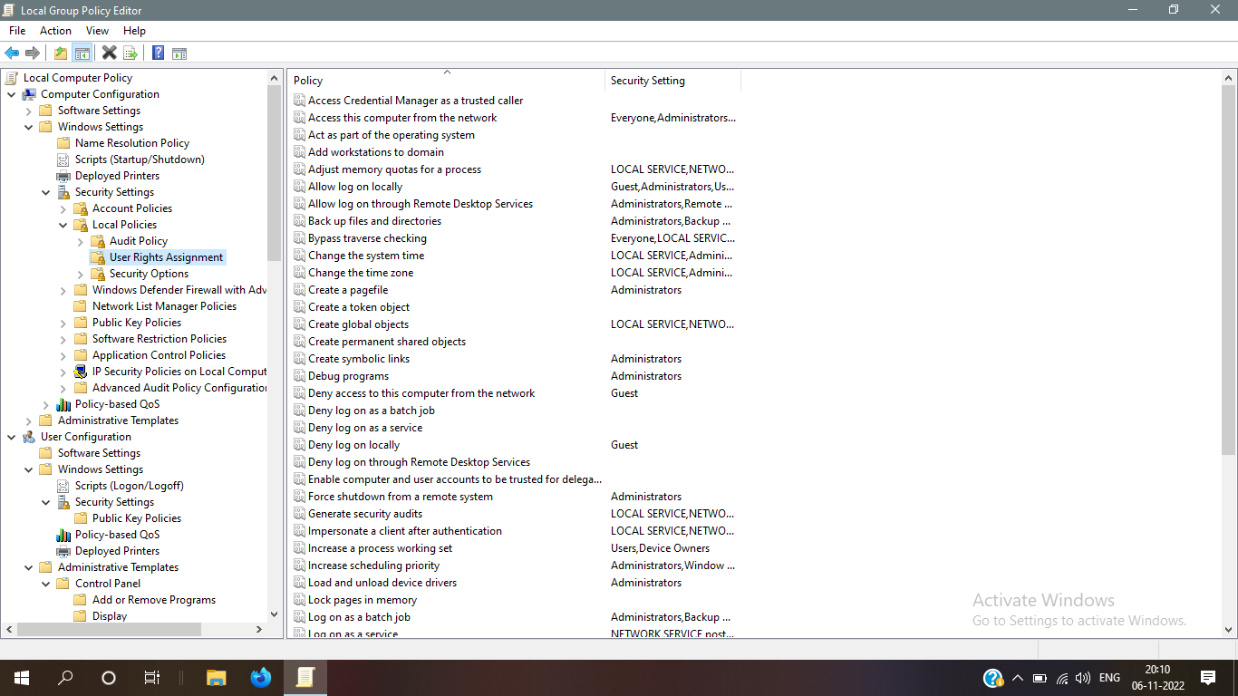

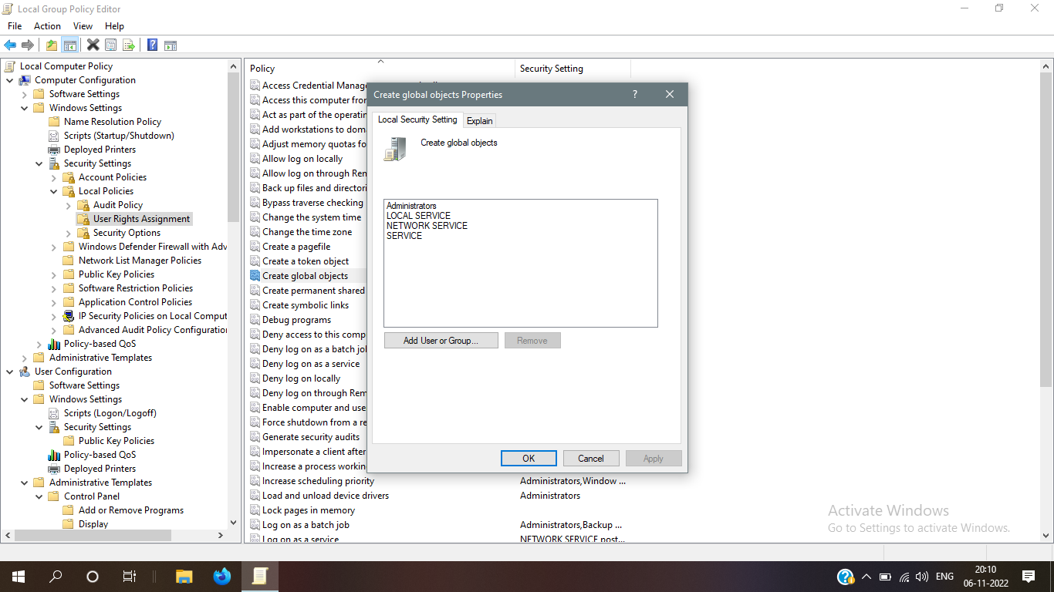

Administrative Users
Administrative users have full or restricted access to the Security Groups application and to the Users application. Administrative users are responsible for implementing and maintaining security services, such as adding users, building profiles, or managing general site administration.
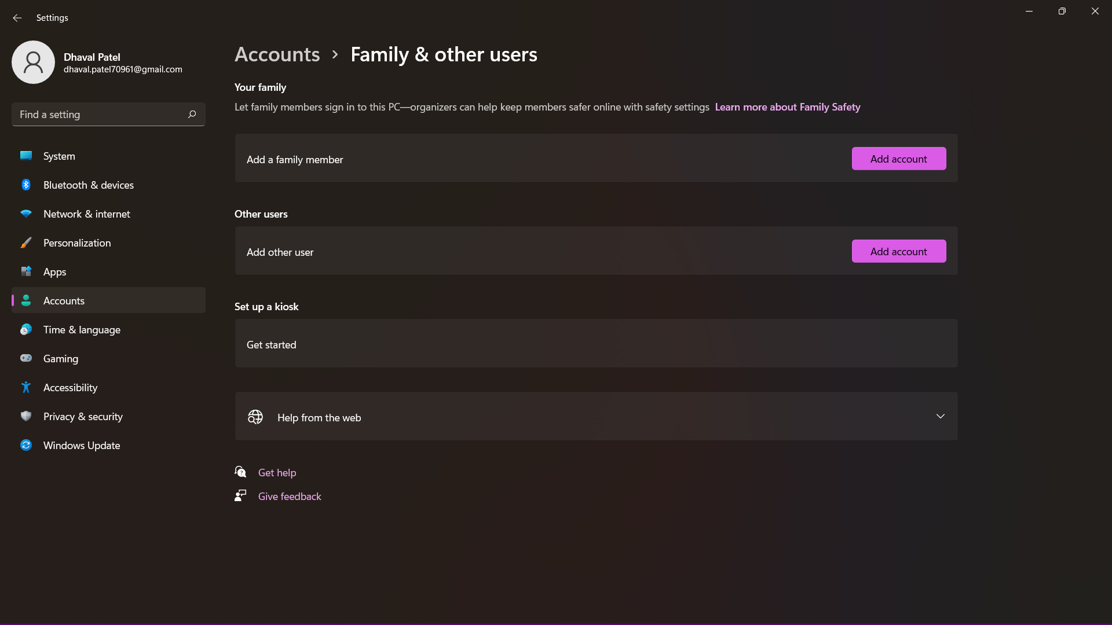

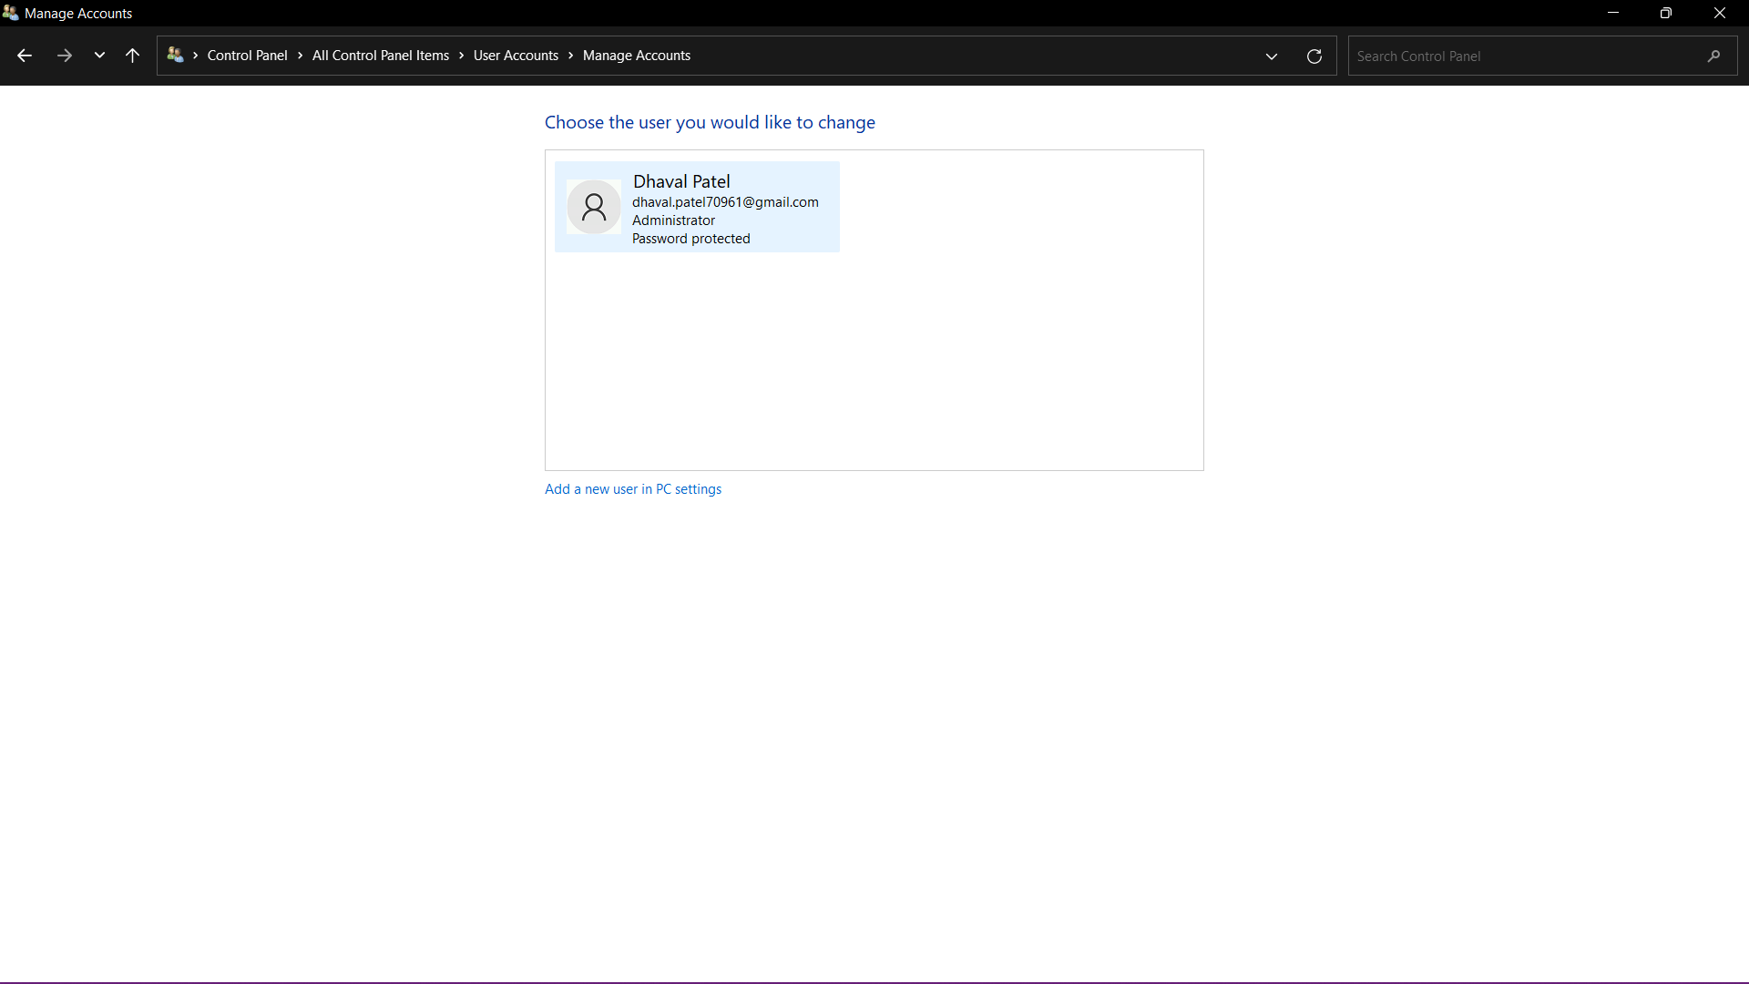
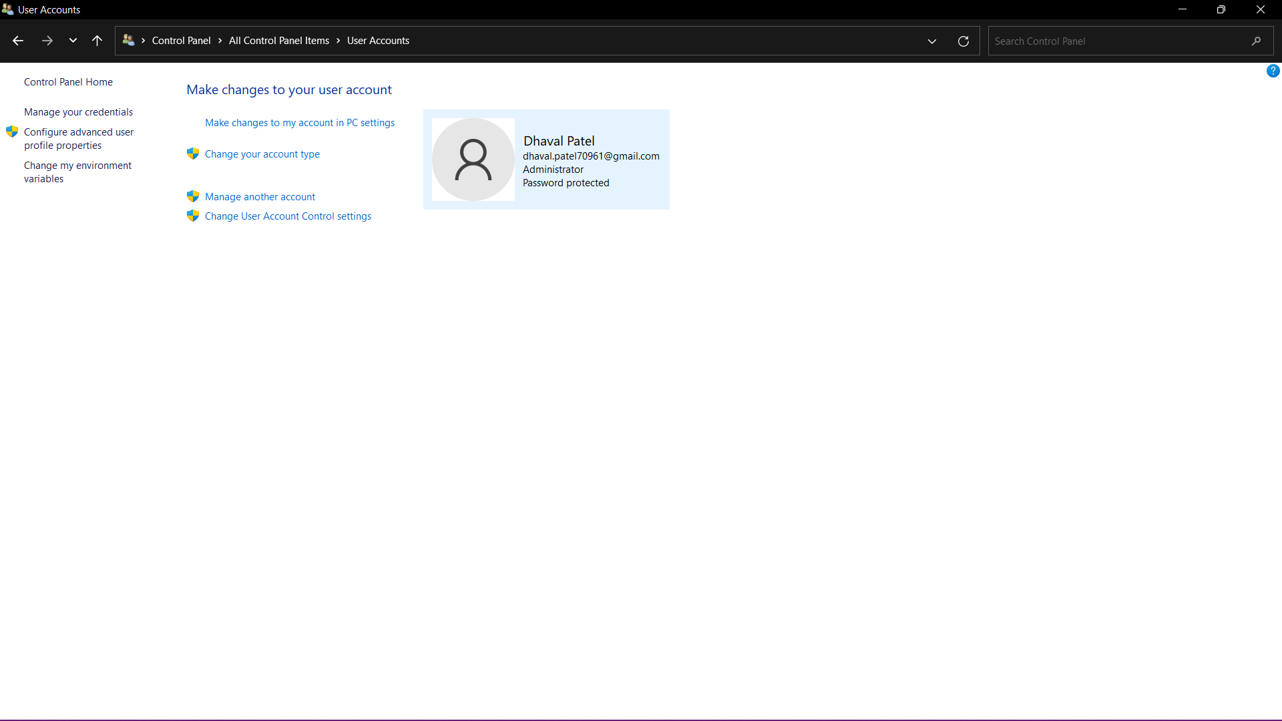

User Account Control
User Account Control (UAC) helps prevent malware from damaging a PC and helps organizations deploy a better-managed desktop. With UAC, apps and tasks always run in the security context of a non-administrator account, unless an administrator specifically authorizes administrator-level access to the system.
